Swachha Bharat Pakhawra-2018
16 December – 31 December
ICAR-Central Inland Fisheries Research Institute, Barrackpore, Kolkata

Institute: ICAR-Central Inland Fisheries Research Institute

Day: 21.12.18
Awareness Generation activities on mental health awareness

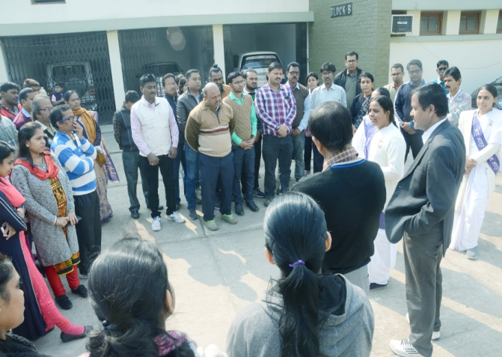
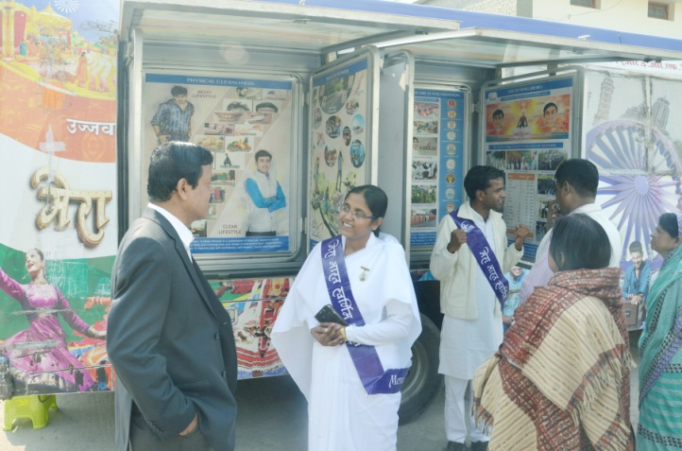
ICAR-CIFRI took initiative on awareness generation on mental health among the staff members through “Mental cleanliness” exercises in collaboration with the Prajapita Brahma Kumaris Ishwariya Vishwa Vidyalaya. The social workers and volunteers associated with Prajapita Brahma Kumaris Ishwariya Vishwa Vidyalaya were invited to the institute for disseminating knowledge and awareness about need of mental health awareness in the present context. They spoke on psychological distress, its effect and remedial measures through meditation and Yoga. All the staff of ICAR-CIFRI gathered and took active participation in the activities and exercises carried out by the volunteers on stress management and concentration building.
